**Featured on the Accenture Metro DC Portal

**Metro DC Celebrates 2018 Annual Day of Service**

**October 25, 2018**

**By:** [**Hirdesh Matta**](https://people.accenture.com/collaboration.aspx?accountname=hirdesh.k.matta)

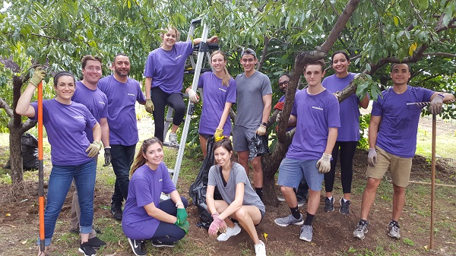

“We continue to grow, we continue to excel and do amazing things,” said Metro DC Office Managing Director [Marty Rodgers](https://people.accenture.com/People/user/martin.w.rodgers) at the Metro DC 11th Annual Day of Service on October 8, 2018.

More than 2,000 Metro DC employees attended the Office-wide Meeting at Lisner Auditorium and participated in projects at 100+ project sites across the Metro DC area, including serving at projects in Baltimore, Annapolis, Richmond and Central Pennsylvania.

Following a high-energy [opening video](https://mediaexchange.accenture.com/media/t/1_jv699ksq), Marty kicked off the meeting discussing the community impact the Metro DC office has had over the past year. Our people in Metro DC led the way in North America with more than $1 million raised for charity and 16,000 volunteer hours contributed.

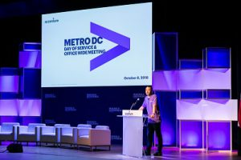

[Julie Sweet](https://people.accenture.com/People/user/julie.sweet), Chief Executive Officer-North America, had a [video message](https://mediaexchange.accenture.com/media/t/1_z1j08ny6) for attendees and discussed the three themes for North America this year: Learn, Connect, and Impact.

[Lisa O’Connor](https://people.accenture.com/People/user/lisa.oconnor), the Global Security Research and Development Lead for Accenture Labs,  
discussed the new Cyber Fusion Center and said, “We’re at the epicenter of cyber security.”

[Sonia Webb](https://people.accenture.com/People/user/sonia.i.webb), North America Finance Director, discussed Accenture’s growth from 2007, when the inaugural Day of Service was held, through today. Since 2007, Accenture has added 289,000 employees globally and increased yearly revenues by $22 billion. Metro DC is the unofficial highest revenue generating local market for Accenture North America.

[Bruce Voelker](https://people.accenture.com/People/user/bruce.d.voelker), Chief Operating Officer for Accenture Federal Services, discussed the importance of giving back and said, “This business is about two things: clients and people.”

Senior Manager [Wendy Chan](https://people.accenture.com/People/user/wendy.l.chan) discussed Accenture’s support of the global refugee crisis, which included supporting the first annual One Journey Festival, a festival celebrating refugee talent and contributions, attended by over 4,000 people.

Keynote Speaker [Derreck Kayongo](https://www.cnn.com/videos/living/2012/01/06/cnnheroes-tribute-kayongo.cnn), Founder of Global Soap Project, electrified the crowd with his humor and insight. Kayongo discussed his background as a refugee and how that experience led to him start his non-profit. He mentioned that Accenture was the first professional organization to support the Global Soap Project.

Kayongo closed his address by saying, “Don’t seek perfection. Seek balance. Seek consistence. Seek justice. Seek passion. Seek a cause for humanity; and your life shall have meaning.”

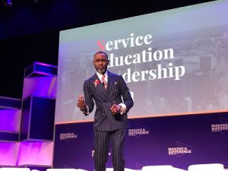

[Ira Entis](https://people.accenture.com/People/user/ira.entis), AFS Managing Director of Strategic Solutions and Emerging Technology, discussed the emergence of artificial intelligence and said it is “the biggest technical revolution of any of our lifetimes.”

[Bashirya Williams](https://people.accenture.com/People/user/bashiyra.williams) led a Corporate Citizenship Panel featuring [Christy DeHaven](https://people.accenture.com/People/user/christine.p.dehaven), [Meghan Perrin](https://people.accenture.com/People/user/megan.s.perrin), [Allen Whiteacre](https://people.accenture.com/People/user/k.allen.whiteacre) and [Roxane Collins](https://people.accenture.com/People/user/roxane.collins), where different Accenture volunteer programs were discussed.

Metro DC Local Market Lead [Roy K. Lee](https://people.accenture.com/People/user/roy.k.lee) led a Jimmy Fallon-esque, “Consultant Confessions” game, featuring new Managing Directors [Robert Hoffman](https://people.accenture.com/People/user/robert.hoffman) and [Maurine Fanguy](https://people.accenture.com/People/user/maurine.fanguy).

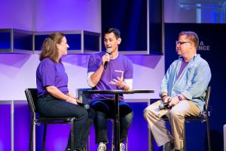

[Lisa Mitnick](https://people.accenture.com/People/user/lisa.mitnick), Managing Director of Industry X.O, Communications Media and Technology NA, discussed how Industry X.O. has allowed Accenture to help companies make the “wise pivot.”

Marty Rodgers hosted a fireside chat with [Dan Porterfield](https://www.youtube.com/watch?v=PezUccPKSpQ), President and CEO of The Aspen Institute, a long-time Accenture Skills to Succeed partner. Porterfield discussed how The Aspen Institute is working towards its mission of addressing some of the world’s major problems. “Nothing that’s worth doing comes easy,” said Porterfield.

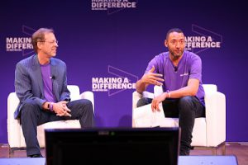

Managing Director [Kevin Laudano](https://people.accenture.com/People/user/kevin.m.laudano) talked about Accenture’s support of the Best Buddies Program. [Max Hershberger](https://people.accenture.com/People/user/max.hershberger) received a standing ovation after [sharing his story](https://www.youtube.com/watch?v=4nMC-L7GLXA&feature=youtu.be) of how the program benefited him and helped him land a job at Accenture.

Marty Rodgers closed out the Office-wide Meeting with one of his favorite quotes, “Never doubt that a small group of thoughtful, committed citizens can change the world; indeed, it’s the only thing that ever has.”

After the morning meeting, attendees grabbed bagged lunches and traveled to more than 100 project service sites.

The day ended with happy hour and networking at The Showroom in DC.

