**Featured on the Accenture Metro DC Portal

**Metro DC Hour of Code Volunteers Teach Nearly 13,000 Students**

**December 20, 2018**

**By:** [**Hirdesh Matta**](https://people.accenture.com/collaboration.aspx?accountname=hirdesh.k.matta)

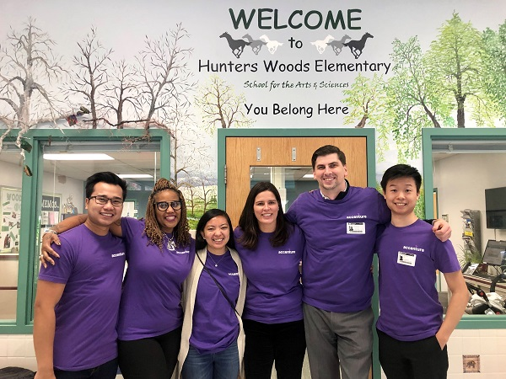

Hour of Code volunteers at Hunter Woods Elementary School in Reston, Va.

At Accenture, we see the opportunities available to those with a STEM education every day. The Bureau of Labor Statistics says employment of computer and information technology occupations will add approximately 557,100 new jobs by 2026. Who will fill that demand? None other than today’s students.

For the fourth year in a row, Accenture teamed up with Code.org to support [Hour of Code](https://code.org/learn)—a grassroots movement to empower every student in every school to learn to code. [Accenture hosted events](https://twitter.com/i/moments/1067129701943181312) around the world the week of December 3, which aligns with Computer Science Education Week.

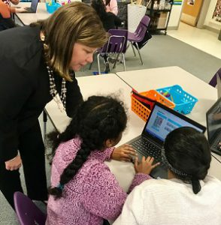

Annette Rippert, Senior Managing Director – Technology, at Glebe Elementary in Arlington, Va.

Metro DC Office’s Senior Managing Director [Marty Rodgers](https://people.accenture.com/People/user/martin.w.rodgers) kicked off Accenture’s Hour of Code on December 3, at Fort Worthington Elementary/Middle School in Baltimore, alongside Baltimore Mayor Catherine Pugh and Baltimore City Public Schools CEO Sonja Santelises.



Marty Rodgers, Baltimore Mayor Pugh and students from Fort Worthington Elementary/Middle School

“It is critical that we equip today’s students – tomorrow’s workforce – with not just tech skills, but also an understanding of how they can harness creativity and innovation to improve the way the world works and lives,” said Marty. “Hour of Code teaches kids that they can pursue a successful well-paid career coding games versus playing them.”

The knowledge gained by the students can help them pursue higher paying jobs, as the median annual wage for computer and information technology occupations was $84,580 in May 2017. That is more than double the median annual wage for all occupations of $37,690.

Throughout the week, nearly 400 of Accenture’s Metro DC people in Washington DC, Baltimore, and Richmond volunteered at more than 120 schools teaching nearly 13,000 students.

In Baltimore, Hour of Code expanded significantly this year and was led by Managing Director [Miruna Burk](https://people.accenture.com/People/user/miruna.p.burk). “We are excited to partner with the Baltimore school system and local partner [Code in the Schools](https://www.codeintheschools.org/) to help make Baltimore #thecitythatcodes,” said Burk.

Burk started the initiative in Baltimore by volunteering in her daughter’s classroom in 2016 and expanded to the entire school with 40 volunteers in 2017. The initiative took a major step forward in 2018 with more than 350 volunteers from 65 organizations in 50 schools. Through its volunteer efforts, Hour of Code events across Baltimore reached more than 10,000 students in 2018.

[Amanda Smith](https://people.accenture.com/People/user/amanda.c.smith) and [Benno Lee](https://people.accenture.com/People/user/benno.lee) were among the volunteers who participated in Hour of Code. Amanda volunteered at Round Hill Elementary School in Round Hill, Va., and had one student say, “this was the best day of coding ever,” at the conclusion of the program. Benno taught third graders at Sleepy Hollow Elementary School in Falls Church, Va., and after being apprehensive, was impressed by the knowledge of the students.

“I was initially really anxious about Hour of Code because I had never worked with children before,” said Benno. “I needn’t have worried since the kids took to the activities and ran with it. There were some very bright and creative students. By the end, they were coding, customizing and collaborating to create new games from coding blocks.”

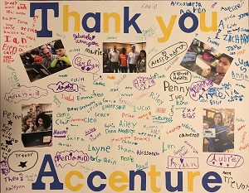

Thank you note from students at Fox Mill Elementary School in Herndon, Va.

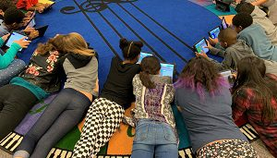

Students coding at Hoffman-Boston Elementary School in Arlington, Va.

With another year of Hour of Code complete, it is clear to see that Metro DC people continue #makingadifference. The countdown to next year has already begun.

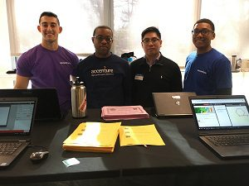

Hour of Code volunteers at Ron Brown College Preparatory School in Washington

“The impact that our volunteers have made over the last three years has been significant, said Managing Director [Rob Hedges](https://people.accenture.com/People/user/robert.hedges), who leads the Metro DC Hour of Code effort. “Feedback from students and teachers has been consistently glowing, and in many cases ongoing relationships have been forged, with our people returning year-round to their schools to volunteer their time. We’re looking forward to doing it all again in 2019.”