**Progressing to Now**

IT infrastructure is the combination of an entity’s collection of hardware, software, networks, data centers, facilities, and related equipment used to develop, test, store, operate, monitor, manage and support information technology services. OSOHE continues to optimize its IT infrastructure, including the adoption of relevant technologies, and we thought it would be interesting to analyze the journey of industry advancements and SSA’s progression throughout history.

While change is risky, it is necessary for SSA to continue providing a superior customer experience based on changing needs and technological expectations of our customers, especially when it involves an infrastructure that is the foundational layer for vital services provided to all American citizens.

We have come a long way since our inception in 1935 as an entirely new entity, the Social Security Board. In 1935, we had no staff, no facilities, and no budget. Over the 80+ years of SSA’s existence, the technology and IT infrastructure has evolved substantially, and as we now begin utilizing cloud computing, we continue to benefit from industry advancements.

Early progression of IT infrastructure started in the 1950s with IBM announcing the first fully electronic data processing system, the IBM 701. In 1959, a joint effort of industry, universities, and the US Government introduced the Common Business Oriented Language (COBOL).

Continuing its tradition as an early adopter of technology, SSA began using COBOL and the IBM 701 to process its retirement and disability claims. Today SSA maintains over 60 million lines of COBOL, along with newer coding languages, including 29 million lines of Java, 5 million lines of ColdFusion, and 5 million lines of C/C++/C#. Whether it is the use of newer coding languages, newer infrastructure, such as cloud, or new data technologies, SSA continues to look for ways to use technology to modernize and improve services.

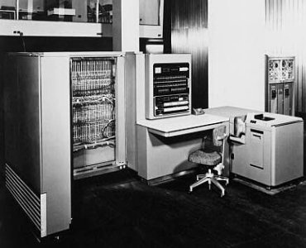

Figure 1 The IBM 701 became our automated platform in the 1950s to process retirement and disability claims.

In the 1960s, the first wide area network (WAN) was developed along with a time-sharing system which led to the foundation of UNIX. The IBM S/360 mainframe computer system family was also introduced in 1964 and covered the complete range of applications, from small to large, both commercial and scientific.

SSA’s Master Data Access Method (MADAM) software is built on the record-based file/index system that ran on IBM S/360 and in the mid-2000s was running on its modern mainframe hardware. Today, SSA’s mainframes manage 900 databases, and are able to process 180 million earning records and handle 175 to 195 million daily online transactions, on average. The mainframes also have 20 petabytes of raw storage capacity.

The 1970s saw the introduction of relational databases with Oracle V2 becoming the first commercially sold RDBMS. The 1980s was a major decade in the progression of IT infrastructure with the introduction of the personal computer (IWS/LAN) and SQL Server 1.0, among other major technologies.

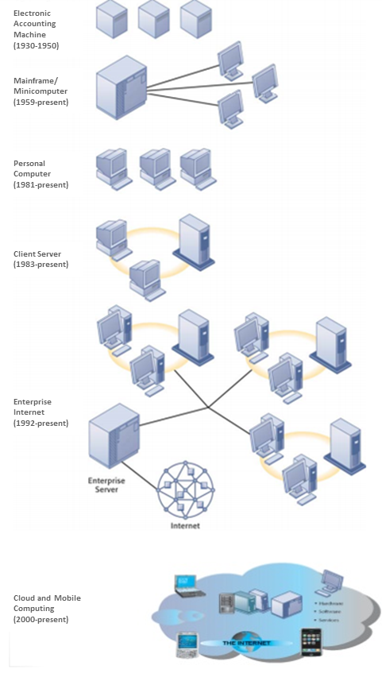

Figure 2 Our infrastructure continues to leverage relevant technological advances with strategic modernization initiative to support Programmatic and Admin/MI functions.

In 1990, the first incarnation of the World Wide Web was created. The 1990s also saw the creation of Linux, Red Hat, MYSQL, Microsoft Exchange, and VMWare 1.0.

Using a method that minimizes risk to the services we provide, the Agency has implemented many of these new technologies to modernize its infrastructure. In 2015, SSA did a pilot-use of a Linux server, and decided to undertake a multi-year project to migrate away from, and ultimately retire, its proprietary mid-tier UNIX servers to more flexible Linux servers.

In 2006, AWS EC2 was introduced allowing for public clouds. Agile and DevOps were both popularized in the late 2000s as well. SSA has leveraged both cloud technologies and the Agile development model on a number of new projects including the Enterprise Data Warehouse and Disability Case Processing System.

Agile differs from the traditional waterfall development method, in that Agile calls for brief development sprints, with rounds of design, testing, and feedback to deliver incremental product updates. With this model, development is ongoing, as tests and adjustments continue after the project is in use. This method allows us to modernize more rapidly and focus on smaller chunks of functionality, decreasing our risk of service interruptions to those who depend on our applications.

In addition to hardware and software, the Agency has also started to update its facilities by migrating some of its systems to a new modern, efficient, Tier-3 data center with double redundancy. In 2016, SSA completed the systems migration from the National Computer Center (NCC) to the new National Support Center (NSC). These systems contain demographic, wage, and benefit information for almost every American, and the data is essential for SSA to provide services to its customers. The Center is LEED Gold certified and has 64% virtualization of open systems platforms. The mainframe environment has 28 logical systems, 90 General Processor engines, 72 z-Series Integrated Information Processor engines, 9 z-Series Integrated Information Processors engines, and 77 Capacity Back-Up engines.

In looking at the history of industry advancements and SSA’s adoption, we realize that adding cloud computing to our repertoire of IT infrastructure services is just another step in the overall progression. It does not mean we can eliminate our existing infrastructure baselines, but where possible, we can benefit from the on-demand, scalable nature of the cloud. It provides us added insight into our resource usage and needs, as we only pay for what we utilize. Our data centers can be reduced in size without having an impact on the IT capabilities.

As IT infrastructure continues to evolve, we can look forward to the Agency being a front-runner within the government in leveraging new technologies. At a high-level, we have a roadmap of our vision for the next three years, which includes an on-premise cloud, PaaS, SaaS, and expansion of our IaaS. In future postcards, we will continue to provide updates on our progress and details of this vision as they become reality.